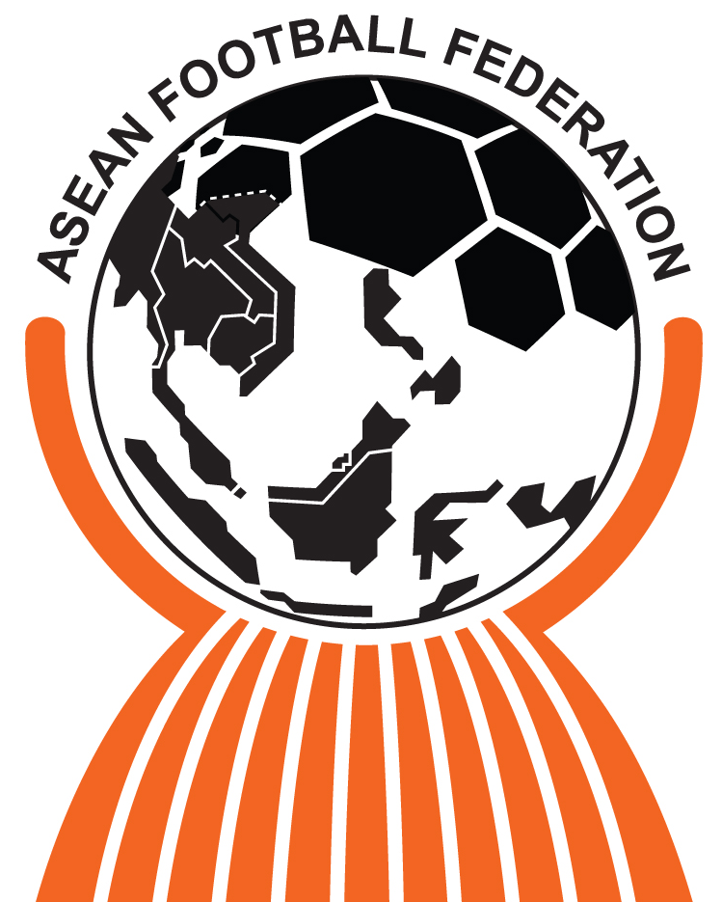  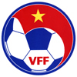 |  |  |  |  |  |  |  |  |  |  |  |  |  |  |  |  | MATCH NO:
AFF U19 TOURNAMENT 2012 |  |  |  |  |  |  |  |  |  |  |  |  |  |  |  |  | 1
HO CHI MINH CITY, VIETNAM
2 – 8 SEPTEMBER 2012
TEAM A : |  | AUSTRALIA |  |  |  |  |  |  |  |  | TEAM B : |  |  | UZBEKISTAN
JSY COLOUR : |  | GOLD – GREEN – GOLD |  |  |  |  |  |  |  |  | JSY COLOUR : |  |  | WHITE – WHITE - WHITE
PLAYED AT : |  | THONG NHAT STADIUM |  |  |  |  |  |  |  |  | DATE : |  |  | 2ND SEP 2012 |  | TIME : |  |  |  | 1600
JSY | NAME |  |  |  |  |  | P |  | S | N | JSY | NAME |  |  |  |  |  | P | S |  | N
1 | NICHOLAS JOHN MUNRO (GK) |  |  |  |  |  | V |  |  |  | 1 | AMANOV ASILBEK (GK) |  |  |  |  |  | V
2 | JASON KATO GERIA |  |  |  |  |  | V |  |  |  | 3 | SHAYKULOV ISKANDAR |  |  |  |  |  |  | X
3 | CONNOR EDWARD CHAPMAN |  |  |  |  |  | V |  |  |  | 4 | YULDASHOV BOBURBEK |  |  |  |  |  | V
4 | DANIEL PETKOVSKI |  |  |  |  |  | V |  |  |  | 5 | SABIRKHODJAEV SARDOR |  |  |  |  |  |  | X
5 | COREY EDWARD BROWN |  |  |  |  |  | V |  |  |  | 6 | MAKHSTALIEV ABBOSBEK |  |  |  |  |  | V
6 | REECE CAIRA |  |  |  |  |  | V |  |  |  | 7 | KOZAK VLADIMIR |  |  |  |  |  | V
7 | RYAN EDWARDS |  |  |  |  |  |  |  |  | O | 9 | ABDUMUMINOV JAHONGIR |  |  |  |  |  | V
8 | TERRY ANTONIS |  |  |  |  |  | V |  |  |  | 10 | ISKANDEROV JAMSHID |  |  |  |  |  |  | X
9 | ADAM JAKE TAGGART |  |  |  |  |  | V |  |  |  | 12 | TURSUNBAEV AKMAL (GK) |  |  |  |  |  |  | X
10 | JAKE KEITH BARKER-DAISH |  |  |  |  |  |  |  | X |  | 14 | MIRABDULLAEV JAVLON |  |  |  |  |  | V
11 | BENJAMIN GARRUCIO |  |  |  |  |  | V |  |  |  | 16 | FOMIN MAKSIMILIAN |  |  |  |  |  |  | X
12 | JESSE DAVID MAKAROUNAS |  |  |  |  |  |  |  |  | O | 17 | SERGEEV IGOR |  |  |  |  |  | V
13 | RILEY WOODCOCK |  |  |  |  |  |  |  | X |  | 18 | UBAYDULLAEV MUHSINJON |  |  |  |  |  | V
14 | MITCH STEVEN BAGGIO COOPER |  |  |  |  |  | V |  |  |  | 19 | SAIDOV JALOLIDDIN |  |  |  |  |  | V
15 | CHRISTOPHER JOSIF HAGI GLIGOR |  |  |  |  |  |  |  | X |  | 20 | TASHPULATOV IHTIYOR |  |  |  |  |  |  | X
16 | HAYDEN MORTON |  |  |  |  |  |  |  | X |  | 25 | YUSUPOV ABDUL AZIZ |  |  |  |  |  |  | X
17 | BRANDON MYLES DARRAGH O’NEILL |  |  |  |  |  | V |  |  |  | 26 | MURATOV AZIZBEK |  |  |  |  |  | V
18 | PAUL DAVID IZZO (GK) |  |  |  |  |  |  |  | X |  | 27 | REKUN SERGEY |  |  |  |  |  |  | X
19 | LUKE ANTHONY O’DEA |  |  |  |  |  |  |  | X |  | 33 | SHAMSHITDINOV TOHIRJON |  |  |  |  |  | V
20 | DAVID VRANROVIC |  |  |  |  |  |  |  | X |  | 34 | TUKHTAEV AMAL |  |  |  |  |  |  | X
PAUL OKON-ENGSTLER |  |  |  |  |  |  |  |  |  |  | MUSAEV AKHMADJAN
HEAD COACH (SIGNATURE) |  |  |  |  |  |  |  |  |  |  | HEAD COACH (SIGNATURE)
REFEREE |  |  |  | : |  | Mr MUHAMMAD TAQI ALJAAFARI (SINGAPORE)
ASSISTANT REFEREE I |  |  |  | : |  | Mr RONNIE KOH MIN KIAT (SINGAPORE)
ASSISTANT REFEREE II |  |  |  | : |  | Mr MIN MIN TUN (MYANMAR)
FOURTH OFFICIAL |  |  |  | : |  | Mr HLA MIN (MYANMAR)
MATCH COMMISSIONER |  |  |  | : |  | Mr CHAICHOK POOMPUANG (THAILAND)
REFEREE ASSESSOR |  |  |  | : |  | Mr MOHD RODZALI YAACOB (MALAYSIA)
GENERAL COORDINATOR |  |  |  | : |  | Mr KO KO THEIN (MYANMAR)
P = PLAYING (√) |  |  | S = SUBSTITUTE (X) |  |  |  |  |  |  |  |  |  | N = NOT ELIGIBLE |  | () SUSPENDED  (O) INJURED

